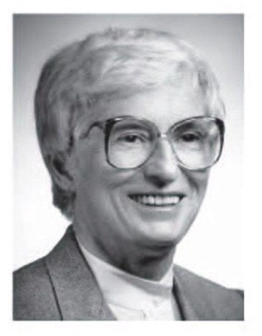 | ANN MACTIER  LEADERSHIP FOR LEARNING  AWARD  School Board Member of the Year APPLICATION

The Nebraska Association of School Boards (NASB) and the Nebraska State Board of Education jointly sponsor this award that recognizes local school board members for their policy leadership and contributions to curriculum and instruction in Nebraska public schools.

The Ann Mactier Leadership for Learning Award Selection committee will review all applications and select an honoree. The Selection committee will include: NASB board member; State Board of Education member; Nebraska Department of Education (NDE) staff; and two local board members from districts that do not have a nominee.

APPLICATION GUIDELINES
Local and ESU board members who have served a minimum of four years are eligible to receive this award.  Nominations can be made by a member of the: local school board; ESU local board; State Board of Education; local or state PTA; local school administrator or teacher; NDE staff; NASB staff; or community business leaders. The president of the local board on which the nominee currently serves must sign the application.  Applications may include up to three letters of support.  Applications will not be returned. | The honoree selected must attend the Luncheon  during the State Education Conference at the La  Vista Conference Center.  Questions and requests for application forms should be directed to NASB, Marcia Herring, 800-422-4572, or NDE, Scott Swisher,  402-471-5024.  Applications must be postmarked or emailed no later than September 25. Send to  NASB, Attn: Marcia Herring  1311 Stockwell ST., Lincoln, NE 68502  Email to mherring@nasbonline.org

BACKGROUND INFORMATION
This award was established in 2004 in honor of Ann Mactier, a 15-year member of the Omaha Board of Education and a past member of the State Board of Education. Ms. Mactier dedicated many years to strengthening curriculum and instruction in Nebraska. The goals of this award are to encourage and recognize outstanding local board leadership in curriculum and instruction.
TIMELINE
July 1 Application brochure available
September 25 Postmark deadline for receipt of applications
November Recognition during a Luncheon at the State Education Conference
Jointly sponsored by:
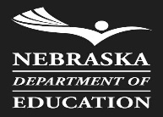 | Nebraska Department of Education  301 Centennial Mall South,  P.O. Box 94987  Lincoln, NE 68509 | Nebraska Association of School Boards  1311 Stockwell Street  Lincoln, NE 68502 | 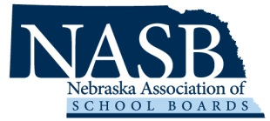

Ann Mactier Leadership for Learning - APPLICATION
Nominee’s Name School District
Home Address District Office Address
City Zip Code City Zip Code
Home Phone District Office Phone
E-mail
Nominator Local Board President
Phone Phone
Email Address Email Address
Local Board Service
Name of local school board Years of service on the local school board
Current office held on the local school board
Past offices held on local school board
Association Participation
State and National Conferences

Workshops

Awards/Honors

Other Education-Related Public Services
Commissions, Task Forces and Committees

Personal Information
Community Activities

Awards and Recognitions

Hobbies and Activities

STATEMENT OF ENDORSEMENT
Please provide a statement about the nominee that addresses the local board member’s contributions to policy leadership in the development of curriculum and instruction. Other topics may include philosophy of education, general board leadership and education completed by the nominee in the area of school board development. The Statement of Endorsement must not exceed a maximum of 500 words and may be attached to this application.

Nominator’s Signature (Required) Local Board President’s Signature (Required)

