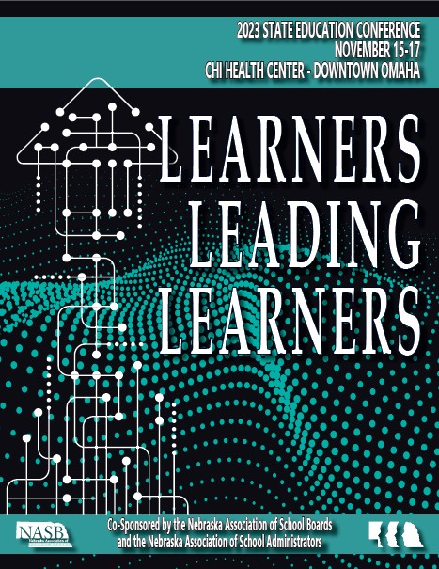
Student Nomination Form

2023 NASB/NASA State Education Conference
November 15-17, 2023
Session: C1 —“Student Voices”
Date: Thursday, November 16, 2023
Location: CHI Health Center
Meeting Time: 1:00 – 2:00 PM
Session Time: 2:15 – 3:15 PM

— PLEASE COMPLETE —
Student Name:
Address:
City, State, Zip:
Home Phone:
Email Address:
Grade:

School Contact:
Title:
School Address:
City, State, Zip:
Work Phone:
Email Address:

Parent(s)/Legal Guardian
Address:
City, State, Zip:
Home Phone:
Work Phone:
Email Address:
Student Biography

2023 NASB/NASA State Education Conference
November 15-17, 2023

Session C1—“Student Voices”
Thursday, November 16, 2023

Using the space below, submit a brief biography outlining school activities, significant achievements, and any other information that would be included in the student introduction, if selected. PLEASE PRINT

Student Name:
School Name:

Student Biography:

Guardian Release Form

2023 NASB/NASA State Education Conference
November 15-17, 2023

Session C1—“Student Voices”
Thursday, November 16, 2023

I understand that my child, ________________________________ (student name), has been invited to participate as a panelist in Session C1, “Student Voices” during the 2023 NASB/NASA State Education Conference on Thursday,
November 16, at the CHI Health Conference Center. I understand that the students, including my child, who participate on this panel will publicly share information about themselves (including such things as name, age, grade level, school district, and brief biography) and about their personal opinions regarding their educational experiences. I acknowledge photographs of my child may be taken by NASB and/or their representatives and consent to and authorize the use of all photographs, digital images or videotapes in news release and/or educational materials, by NASB. The Conference will make every effort to keep panelists and attendees safe by providing masks for attendees and setting up rooms to ensure social distancing can be maintained. I give permission for my child to participate in person for the 2023 Student Voices panel.

_______________________________________________________
Name of legal guardian (please print)

_____________________________________________________________
Signature of legal guardian Date

